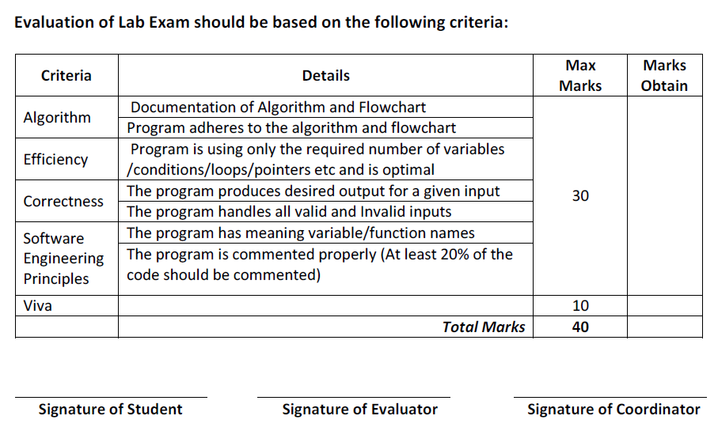
CENTRE FOR DEVELOPMENT OF ADVANCE COMPUTING
Advance Computing Training School

Course Name: PG Diploma in Advanced Computing Batch: March 2024
Module Name: J2EE Date: 03/06/2024
Student Name: Max Marks: 40
Roll No: Duration:
Set - 2

Q1.
Problem Definition 1 a:

Create a Hibernate based application that is used to maintain data about Airlines as per the following:
- Airline Id (Numeric)
- Name (Character Based)
- Employee Count (Numeric)

Write Java programs as per the following:
Program 1:
Accept user input for an airline data and store it into the database.

Program 2:
Accept Employee Count range and display those airlines matching with the Employee Count range.

Display appropriate message if no data found.

Note: Handle Mapping and Configuration without XML

Problem Definition 1 b:

Create a Spring based application that is used to configure Beans holding an information about Airline as mentioned in Problem Definition 1.

(DO NOT COPY AND PASTE THE CLASS. CREATE A SEPARATE ONE)

The application must configure 2 beans as per the following:
- A bean of type Airline holding Airline information
- A bean of type java.util.Map holding Airline ID as a Key and the entire Airline as a Value.

Write a Java program as per the following:
- Load both the beans
- Check whether the loaded Airline bean is available within the loaded Map bean or not and display the appropriate message.

Note:
Handle Java Based Configuration
Implement LAZY loading for both the beans

Problem Definition 2:
Create a REST API that allows users to manage data about Pathological Laboratories.

Laboratory Information:
ID - Numeric
Name - Character Based
Address - Character Based (A Detailed Address including City Name)
Contact No - Character Based

End-Points Description:
GET /labs-api
Loads and displays all the Labs data in JSON format

GET /labs-api/ID
Loads and displays data about a specific lab against its ID

GET /labs-api/CityName
Loads and displays data about specific labs with matching city names

Note:
Use MySQL Database to as a persistent store
Enter some initial records into the corresponding table. (At least 5)
Use Layered Architecture -Controller – Service – Repository
Use 6767 Port Number for the Embedded Tomcat

